Predicting Flight Delays in Commercial Aviation
Mario Alonso López
Aerospace Engineer, Data Science enthusiast

E-mail: m.alonso.lopez123@gmail.com
LinkedIn : https://www.linkedin.com/in/marioalonsolopez/

Published : dd/mm/yyyy
- Abstract
Airborne transportation is widely accepted as a cornerstone in mobility worldwide. Its meaningful impact on the global community is remarkable from a social and economic viewpoint. Societies all across the globe greatly benefit from this industrial activity. However, in order to do so, flight tickets must be fair. Considering the various costs airlines have to face, margins are undoubtedly tight-fitting; so, in order to make it possible for air travelers to fly at a reasonable price, air carriers require minimizing operational costs. There are several challenging tasks an operator has to tackle to maximize its profit, such as optimizing maintenance activities or route planning to minimize fuel consumption. Among all these tasks, this project will focus on predicting flights delays; in accordance with the definition convened by the Federal Aviation Administration (FAA), a flight is considered to be delayed when it is 15 minutes behind its schedule time. According to the FAA, the total cost of delays from 2016 to 2019 has steadily increased from $23.7 to $33 billion ($5.6 to $8.3 billion corresponding to air carriers) ^{[1]}. By addressing the punctuality issue, operators can better understand what the main reasons are behind delays, and set up corrective measures accordingly in advance. Since meteorological predictions are quite accurate nowadays, the proposed model takes this valuable data into consideration in order to generate actionable insights. A comprehensive analysis is undertaken accounting for various predictors besides weather data. In this paper, predictive modelling approaches are applied based on machine learning techniques using publicly available flight and meteorology datasets from the US for year 2019. A binary classifier is built on such data, achieving a Precision-Recall area under the curve (PR-AUC) of 0.XX over the entire dataset.

- Introduction
This paper is mainly based on two datasets retrieved from two main sources, both originating on US data for year 2019:

- On-Time Performance (OTP) ^{[2]}, provided by the US Bureau of Transportation Statistics (BTS)
- Local Climatological Data (LCD) ^{[3]}, provided by the US National Oceanic and Atmospheric Administration (NOAA)

A brief summary of Airline Service Quality Performance is provided below (year 2019) ^{[4]}.

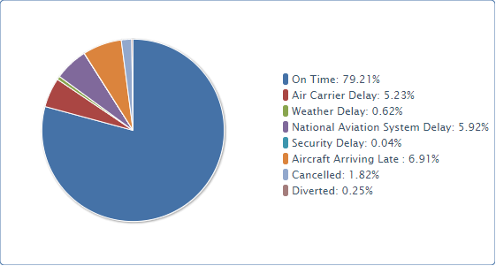
Figure 1. On-Time Arrival Performance National (January - December, 2019)

  - Causes of Delays
There are five categories of delays defined by the BTS ^{[5]}:
- Air Carrier: The cause of the cancellation or delay was due to circumstances within the airline's control (e.g. maintenance or crew problems, aircraft cleaning, baggage loading, fueling, etc.).
- Extreme Weather: Significant meteorological conditions (actual or forecasted) that, in the judgment of the carrier, delays or prevents the operation of a flight such as tornado, blizzard or hurricane.
- National Aviation System (NAS): Delays and cancellations attributable to the national aviation system that refer to a broad set of conditions, such as non-extreme weather conditions, airport operations, heavy traffic volume, and air traffic control.
- Late-arriving aircraft: A previous flight with same aircraft arrived late, causing the present flight to depart late.
- Security: Delays or cancellations caused by evacuation of a terminal or concourse, re-boarding of aircraft because of security breach, inoperative screening equipment and/or long lines in excess of 29 minutes at screening areas.

  - Weather real share
Adverse weather conditions play a central role in the proposed model. Therefore, an in-depth analysis on how to truly calculate meteorological contributions to total flight delays is necessary. A true picture of total weather-related delays requires several steps. First, the extreme weather delays must be combined with the NAS weather category. Second, a calculation must be made to determine the weather-related delays included in the "late-arriving aircraft" category. Adding the weather-related delays to the extreme weather and NAS weather categories would result in weather's share of all flight delays.

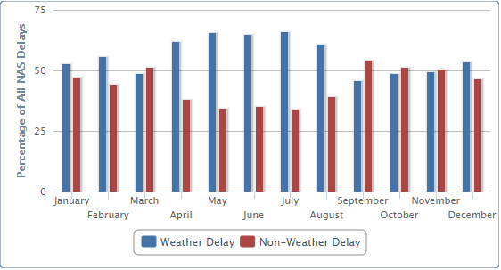
Figure 2. Weather's Share of National Aviation System (NAS) Delays National (January - December, 2019)
Delays or cancellations coded "NAS" are the type of weather delays that could be reduced with corrective action by the airports or the Federal Aviation Administration. During 2019, 56.8% of NAS delays were due to weather. NAS delays were 24.0% of total delays in 2019 ^{[6]}.

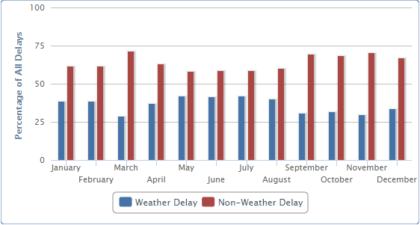
Figure 3. Weather's Share of Delayed Flights National (January - December, 2019)
Weather delay in the figure above is the sum of Extreme Weather delays, NAS delays caused by the weather as assigned by the FAA, and the Weather's pro-rata share of late-arriving-aircraft delays based on delay minutes. According to the BTS, the weather's share of delay as percent of total delay-minutes adds up to 38.7% in 2019 ^{[6]}.

Once weather contribution to delays has been broken down into manageable pieces and properly explained, it is evident that the model is going to be strongly affected by adverse meteorological conditions.

- Related work

- Dataset and Features
  - Datasets
As mentioned above, the paper is built upon two main sources:

- On-Time : Reporting Carrier On-Time Performance (2019) dataset ^{[2]}, supplied by the US BTS
- Local Climatological Data (LCD) ^{[3]}, provided by the US NOAA

The first dataset, referred to as “OTP” herafter, collects individual flights performed by air carriers that account for at least one percent of domestic scheduled passenger revenues. It contains on-time data reported directly by airlines based on the flights they operate. Relevant information such as origin, destination, and time-related data is provided.

The second dataset, from this point forward “LCD”, represents all meteorological-related information gathered by each weather station, providing hourly reports.

Additionally, a third database is used to link the above two datasets, which is the Master Station History Report, provided by the Historical Observing Metadata Repository (HOMR), as part of the National Centers for Environmental Information’s (NCEI) integrated station history database ^{[7]}. This serves as a means to cross-reference each airport and its corresponding weather station.

At this point, some reasonable assumptions had to be made before continuing:

- Not every airport presented its own weather station. Therefore, after a quick analysis on how many airports would be discared by this lack of information, it was found that 18 out of a total of 360 airports would have to be rejected. Fortunately, those minor airports only added up to 0.8% of the flights in the entire dataset. As a result, these flights were dismissed.
- While many weather reports were often provided on an hourly basis, there were a few other which reported more frequently (and not even at the same rate over time). Hence, the observation used in the combined dataset was the first record for each hour. As a result, meteorological conditions at 06:12 and at 06:52 were considered identical. This assumption was required in order to make the analysis feasible.

  - Features
    - OTP
There were originally 109 columns in the dataset and 7.4M records (i.e. flights), so it was initially reduced to 35 to begin with. The data which was held after this initial screening review referred to: time of the flight, airline, origin and destination airports (and their geographic locations), some departure and arrival performance values, and other information such as covered distance and air time.

Some of these columns were kept just for exploratory purposes, and dropped later on in the process. Furthermore, some columns were transformed so the model could use them as input features. For example, it is not possible to have the taxi-in and taxi-out times before the flight, since these are known once the flight is performed; however, a statistical approach can be applied to get the median values for each airport-carrier pair. Taxiing procedures are defined by regulators and made available to all carriers by airports; nevertheless, each airline operates their aircraft in very different ways, so times greatly vary among carriers.

    - LCD
A significant amount of work had to be put into this part of the project. An in-depth analysis was undertaken to assess which features could potentially carry predictive power. At the end, the original number of columns was reduced from 129 to only 14.

The features decided to be kept comprised the station identifier and its geographic location, the reporting date and time, and many various interesting weather variables: altimeter setting (i.e. barometric pressure), dry-bulb temperature, precipitation amount, relative humidity, sky conditions, visibility, and finally wind and gust speeds.

Analogously to what was done on the OTP dataset, various transformations were required to clean this dataset and prepare it for later use in the model. Several reasonable assumptions were made throughout the process, but in order not to excessively elaborate on this topic here, the reader can go into the code for further details.

    - Master Station History Report
This database served as a means of link between the above two datasets. It contains a list of weather stations spread worldwide and, where applicable, their corresponding airport code. As a result, the OTP origin and destination airports could be linked to their corresponding weather station codes. Finally, the latter were used to merge the LCD weather data to the OTP flights. This last step concluded in the final dataset which would be used later on to construct the model.

- Model

- Metrics and results

- Conclusion and future work

- Acknowledgements

- References
- Michael Lukacs, FAA - APO-100 Deputy Division Manager, [2019], Cost of Delay Estimates
- On-Time Performance (OTP) [2019], US Bureau of Transportation Statistics
- Local Climatological Data (LCD) [2019], US National Oceanic and Atmospheric Administration
- Airline Service Quality Performance 234, [2019], US Bureau of Transportation Statistics
- Airline On-Time Performance and Causes of Flight Delays, [March 5, 2020], US Bureau of Transportation Statistics
- Understanding the Reporting of Causes of Flight Delays and Cancellations, [March 5, 2020], US Bureau of Transportation Statistics
- MASTER STATION HISTORY REPORT, Historical Observing Metadata Repository (HOMR), National Centers for Environmental Information’s (NCEI) integrated station history database

